**Institute of Technology Tralee**

**Computing Department**

**Object Oriented Programming 1**

**__________________________________________________**

**Tutorial 11 – Basic Java GUIs**

**Q1**

Write a Java GUI application containing a JFrame window that has 3 labels and a text-field. The JFrame window should be 500x150 pixels in size and make use of a flow-layout layout manager. The application should simply terminate on closing the window.

One of the labels will prompt the user to enter numbers. When the user enters a value and hits return on the text-field an ActionEvent will be triggered. Every time this event occurs, the program should display the current largest and smallest numbers entered by the user, on a second and third label respectively, and clear the contents of the text-field. When the GUI launches initially, the second label should just display the text “No numbers entered yet”, with the third label just remaining blank, as indicated in the first screenshot below.

Note that hitting return on a text-field constitutes an ActionEvent, just like pressing a button, so treat it in exactly the same manner as this code-wise from the point of view of event-handling.

If the user enters nothing at all and proceeds to hit return on the text-field, a message dialog should appear issuing the message indicated in the second screenshot below.

You should make use of the **appendix** of method definitions on the X: drive when answering this question.

Some sample runs of the program are as illustrated below.

**When the application first launches:**

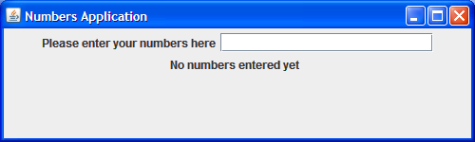

**If the user enters the empty string:**

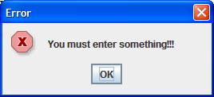

**If the user enters the value 8.56 to begin with – note that the text-field gets cleared of the value just inputted:**

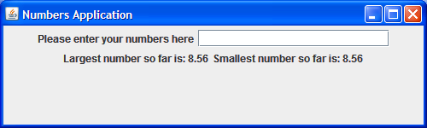

**….. many input values later**

